|  |  |  |  |  |  |
| --- | --- | --- | --- | --- | --- |
| Date | 7-Dec-22 | | | Tester Name | Mohammad Yusuf |
| Environment | Penfax - Test | | | Login used |  |
| Operating System | Select OS | Version: | Update: | | |
| Software Used | Select Software | Version: | Update: | | |
| Select Software | Version: | Update: | | |
| Release version |  | | | | |
| Title | M17 Contributions & DCT | | | | |
| Test Type | Regression | | | | |
| Test Scenario | M17.22 Updating Password | | | | |
|  |  | | | | |
| Expected Results | User should be able to log in with a new password. | | | | |
| Pass/Fail | Pass | | | JIRA# | N/A |

Describe your steps with screenshots:

1. Log in to MEPP DCT and click on Profile.

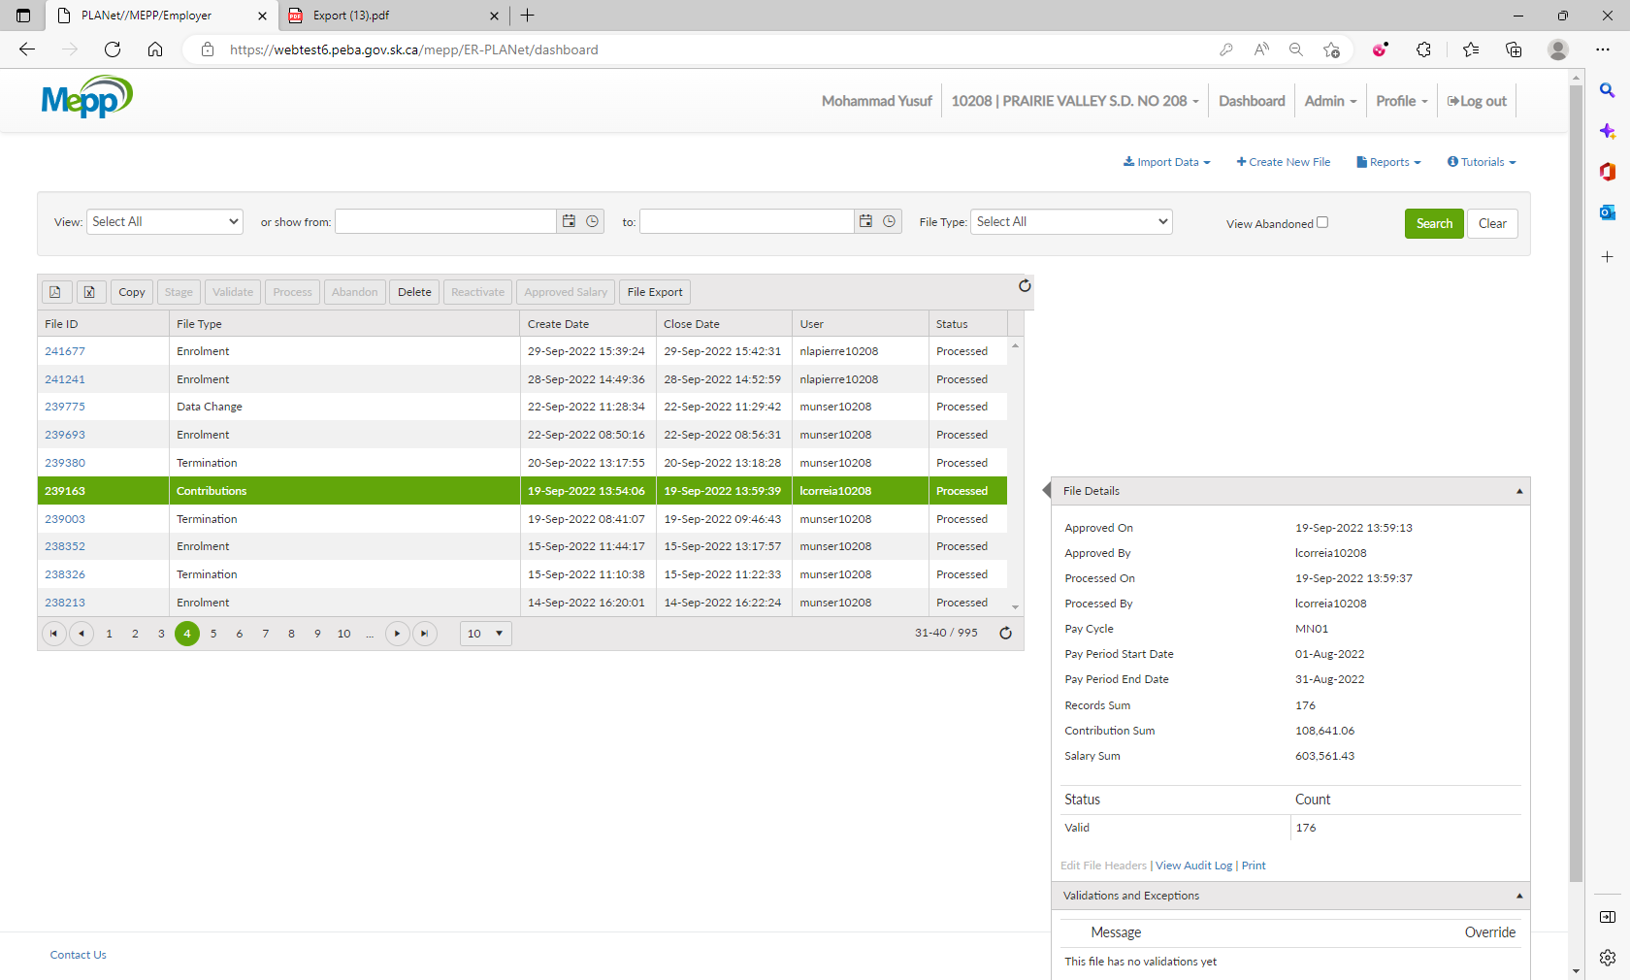

1. Click on Change Password.

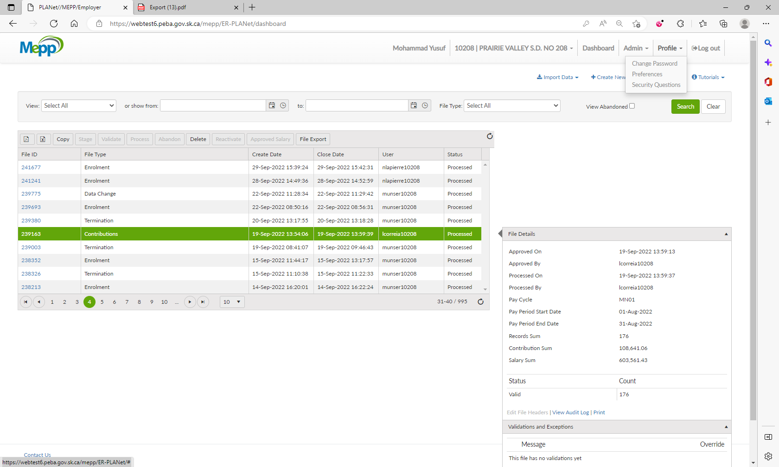

1. Enter your Current Password, New Password and Confirm New Password and then click on

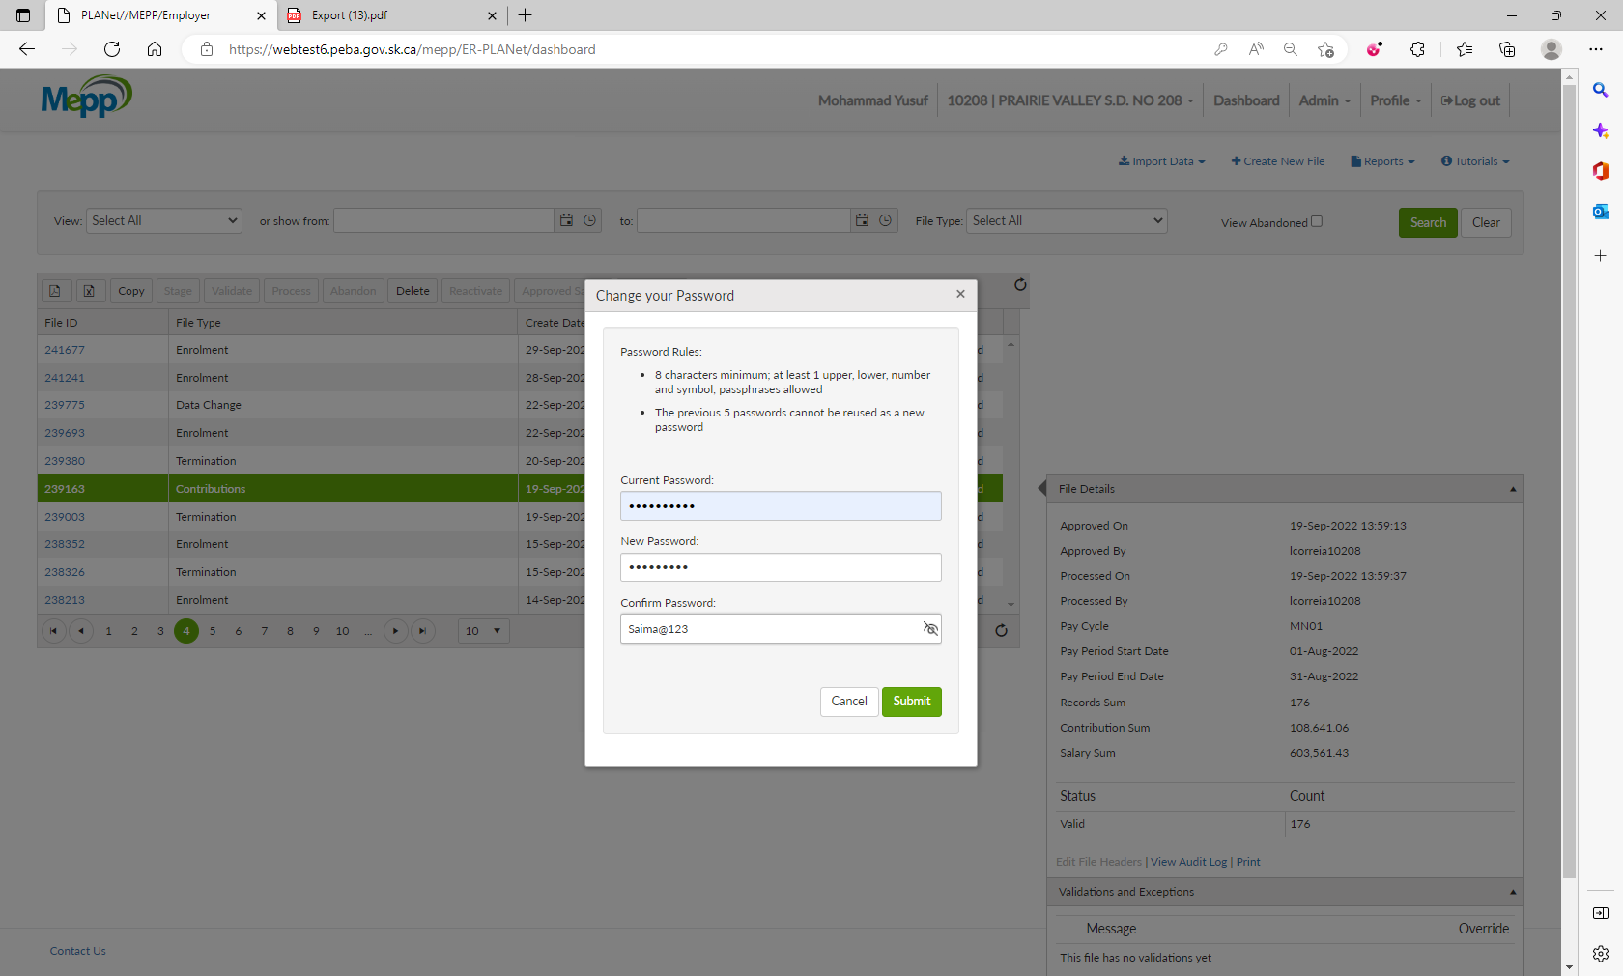

1. You will get the notification.

Quick negative test

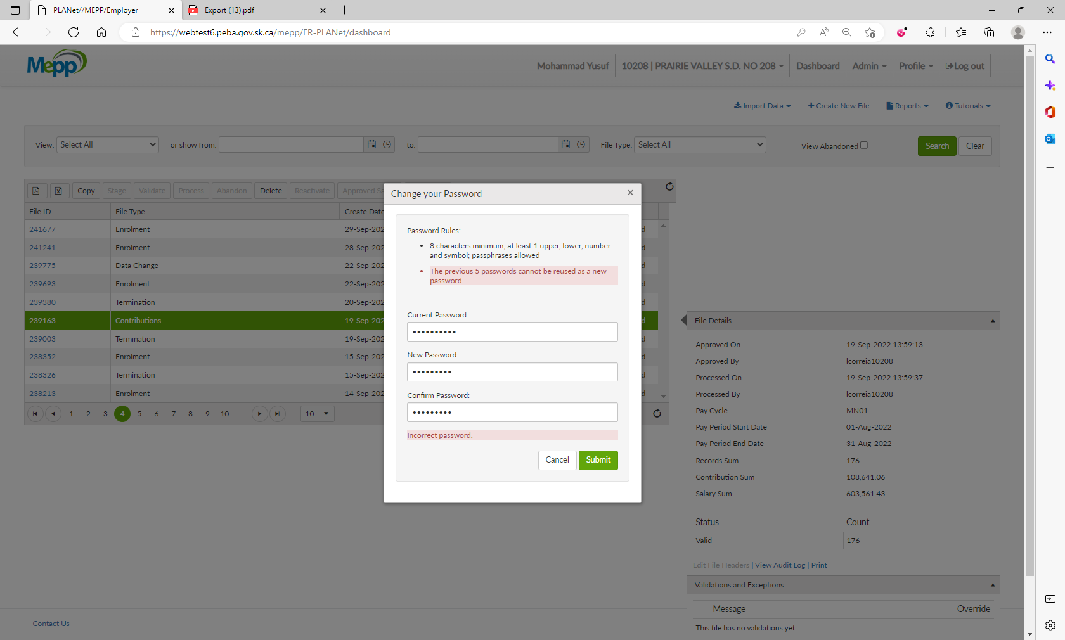

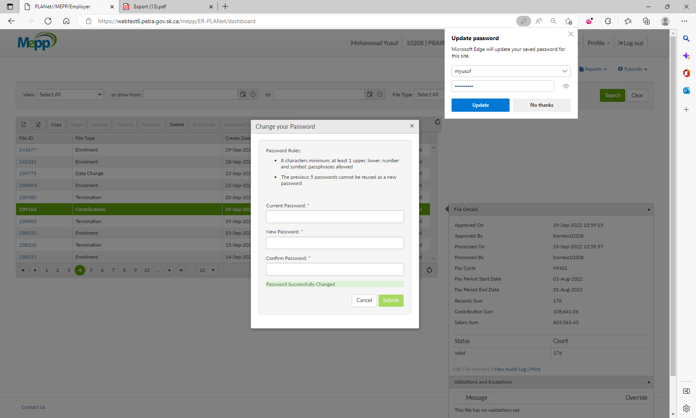

1. Try login with the new password.

